--RFM Analysis | Customer Segmentation
--data ile tanis olaq(20 sutun olduguna gore sekillerin sayi cox oldu)
SELECT * FROM RETAIL_SALES ;

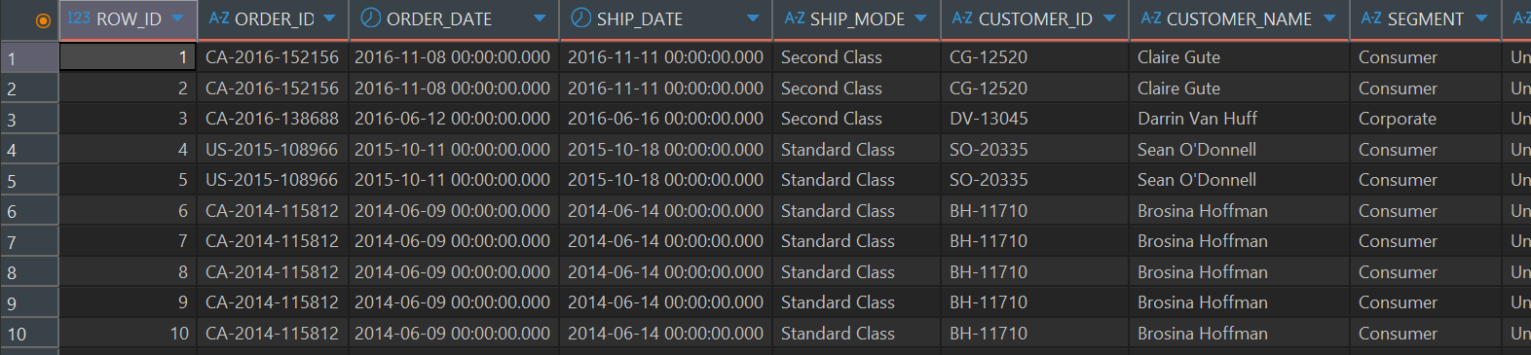
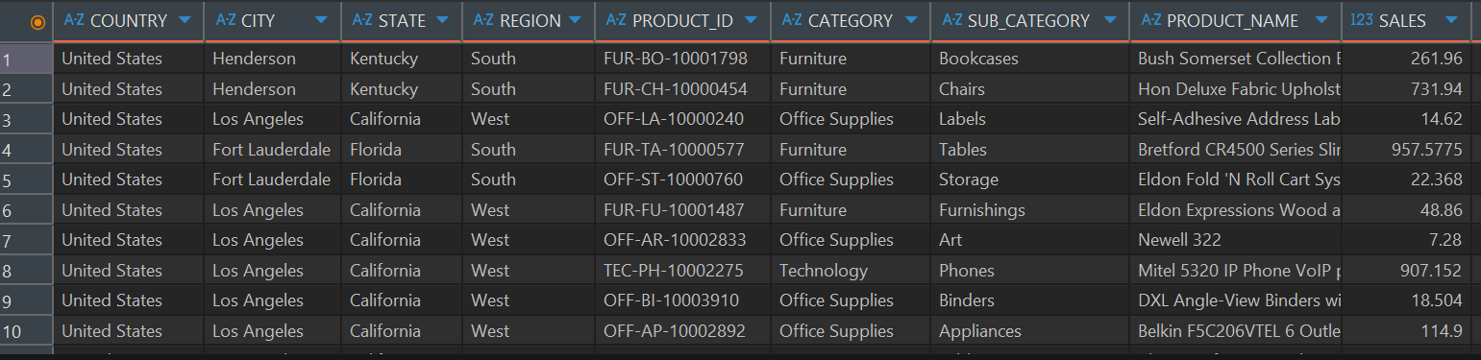
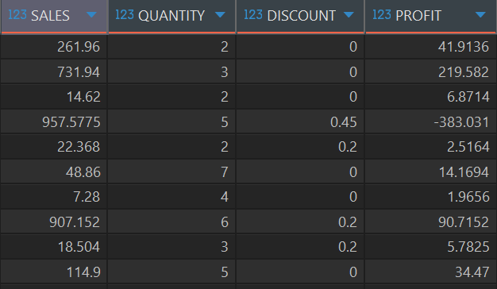

--birinci cedvelin baslangic ve son tarixine baxaq

SELECT
MIN(order_date) min_date,
MAX(order_date) max_date
FROM RETAIL_SALES
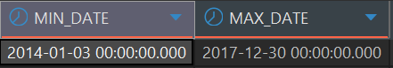
--cedvel kohne tarixleri ehate etdiyine gore cedvelin son tarixini max_date kimi gostermek lazimdir

WITH max_date_table AS (
SELECT
max(order_date) AS max_date
FROM RETAIL_SALES
),

--indi RFM hesablayaq
RFM AS(
SELECT
customer_id,
max_date - MAX(order_date) AS recency,
COUNT(DISTINCT(order_id)) AS frequency,
SUM(sales) AS monetary
FROM RETAIL_SALES r
CROSS JOIN max_date m
GROUP BY r.customer_id, m.max_date
),
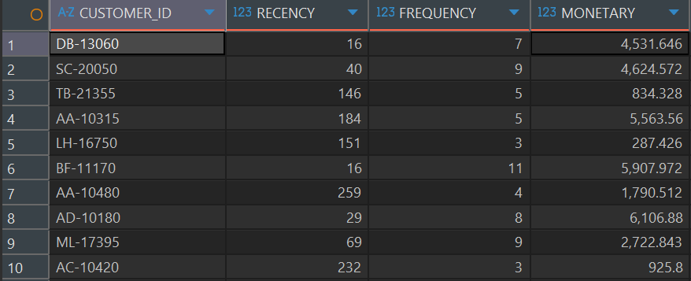
--rfm ucun 1-5 qiymetlerinde skor verek
RFM_score AS(
SELECT
customer_id,
recency,
frequency,
monetary,
NTILE(5) OVER(ORDER BY recency DESC) AS r_score,
NTILE(5) OVER(ORDER BY frequency) AS f_score,
NTILE(5) over(ORDER BY monetary) AS m_score
FROM RFM
)
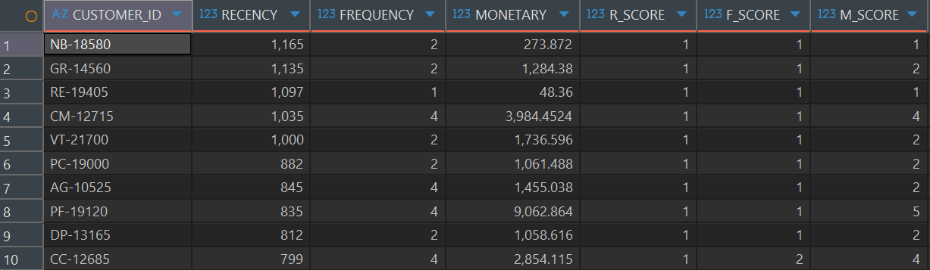

--skor araliqlarini yoxlayaq . burden sonraki hisse range neticesini almaq ucundur. Novbeti addimda qaldigimiz yerden davam edeceyik.
recency_range AS(
SELECT
r_score,
MIN(recency) AS rmin,
MAX(recency) AS rmax
FROM rfm_score
GROUP BY r_score
),
--her biri ucun ayrica hesablanmalidir
frequency_range AS(
SELECT
f_score,
MIN(frequency) AS fmin,
MAX(frequency) AS fmax
FROM rfm_score
GROUP BY f_score
),
monetary_range as(
SELECT
m_score,
MIN(monetary) AS mmin,
max(monetary) AS mmax
FROM rfm_score
GROUP BY m_score
)
SELECT
r.r_score,
r.rmin,
r.rmax,
f.f_score,
f.fmin,
f.fmax,
m.m_score,
m.mmin,
m.mmax
FROM recency_range r
JOIN frequency_range f
ON r.r_score=f.f_score
JOIN monetary_range m
ON r.r_score=m.m_score
ORDER BY r.r_score

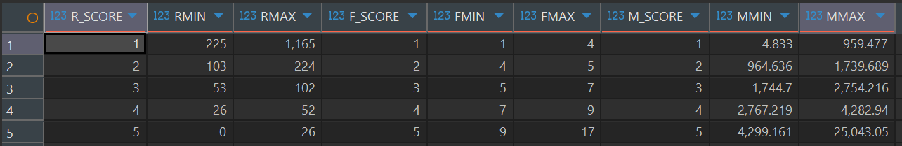

--RFM ortalamasini ve concat neticesini gormek
avg_rfm_concat AS(
SELECT
customer_id,
recency,
frequency,
monetary,
r_score ||'-'|| f_score ||'-'|| m_score AS R_F_M,
ROUND((r_score + f_score + m_score) / 3, 2) AS AVG_rfm
FROM rfm_score
)
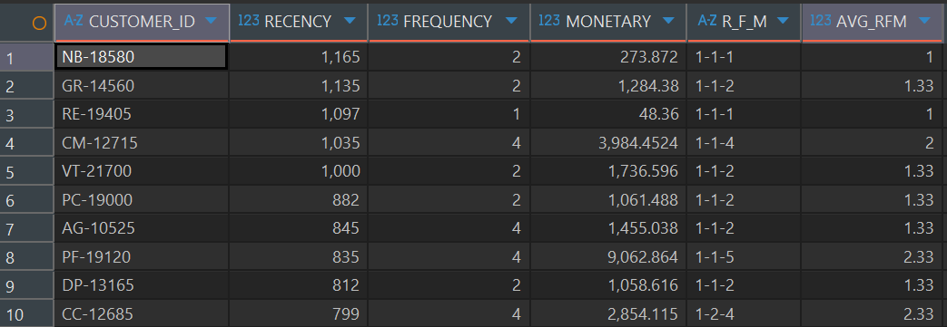

--Müştəri dəyərinə(monetary) görə Low / Mid / High Value yarat. (burada m_score’dan istifade etmek ucun evvelki layere m_score leave etdim)
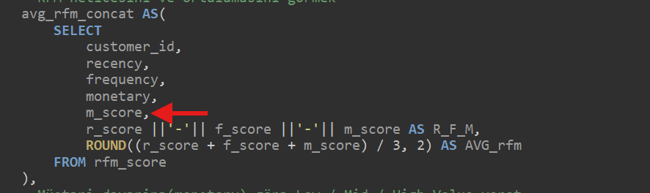
value_seg AS(
SELECT
customer_id,
recency,
frequency,
monetary,
R_F_M,
AVG_rfm,
CASE
WHEN m_score in(1,2) THEN 'low'
WHEN m_score = 3 THEN 'mid'
WHEN m_score in(4,5) THEN 'high'
END AS value_segment
FROM avg_rfm_concat
)
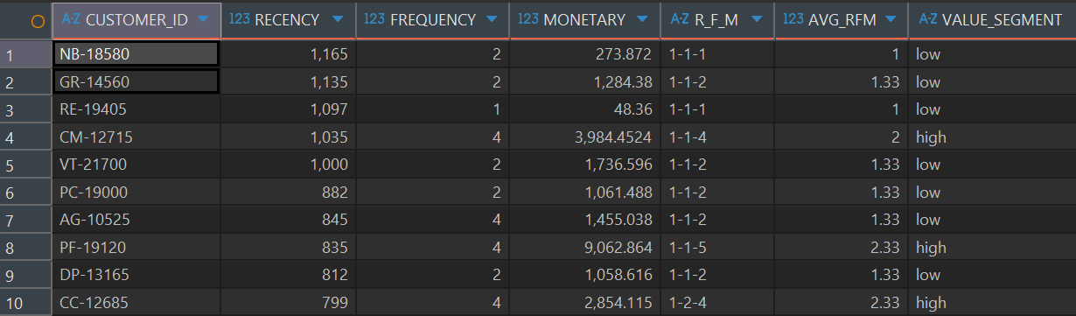

--davranis esasinda segmentler yaratmaq.
--burda bele error aldim ve orgendimki herhansisa sutundan istifade etmek ucun ondan bir evvelki layerde mutleq o sutundan istifade etmelisen.
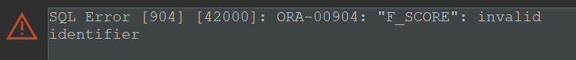
--ve mende evvelki sutunlara elave etdim
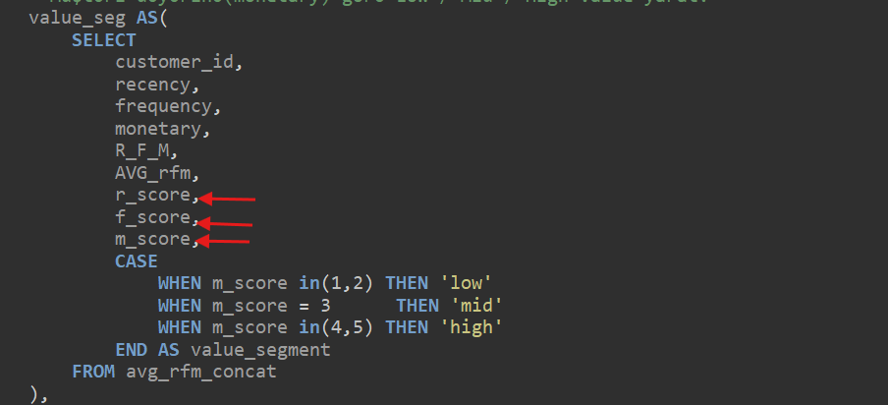
--davam edek.
customer_seg as(
SELECT
customer_id,
recency,
frequency,
monetary,
R_F_M,
AVG_RFM,
value_segment,
CASE
WHEN r_score >=4 AND f_score >=4 AND m_score >=4 THEN 'VIP'
WHEN f_score >=3 AND m_score <4 THEN 'Regular'
WHEN r_score <=3 AND r_score>1 THEN 'Dormat'
WHEN r_score =1 THEN 'Churned'
WHEN r_score >=4 AND f_score <=4 THEN 'New Customer'
END AS cust_seg
FROM value_seg
)
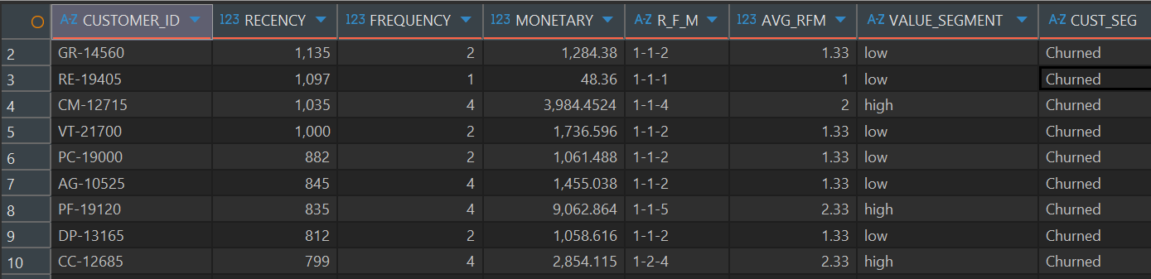

--indi aldigimiz neticeni view ucun yaradaq:
CREATE OR REPLACE VIEW RFM_ANALYSIS AS
WITH max_table_date AS (
SELECT
max(order_date) AS max_date
FROM RETAIL_SALES
),
RFM AS(
SELECT
customer_id,
m.max_date - MAX(order_date) AS recency,
COUNT(DISTINCT(order_id)) AS frequency,
SUM(sales) AS monetary
FROM RETAIL_SALES r
CROSS JOIN max_table_date m
GROUP BY r.customer_id, m.max_date
),
RFM_score AS(
SELECT
customer_id,
recency,
frequency,
monetary,
NTILE(5) OVER(ORDER BY recency DESC) AS r_score,
NTILE(5) OVER(ORDER BY frequency ) AS f_score,
NTILE(5) over(ORDER BY monetary ) AS m_score
FROM RFM
),
avg_rfm_concat AS(
SELECT
customer_id,
recency,
frequency,
monetary,
r_score,
f_score,
m_score,
r_score ||'-'|| f_score ||'-'|| m_score AS R_F_M,
ROUND((r_score + f_score + m_score) / 3, 2) AS AVG_rfm
FROM rfm_score
),
value_seg AS(
SELECT
customer_id,
recency,
frequency,
monetary,
R_F_M,
AVG_rfm,
r_score,
f_score,
m_score,
CASE
WHEN m_score in(1,2) THEN 'low'
WHEN m_score = 3 THEN 'mid'
WHEN m_score in(4,5) THEN 'high'
END AS value_segment
FROM avg_rfm_concat
),
customer_seg as(
SELECT
customer_id,
recency,
frequency,
monetary,
R_F_M,
AVG_RFM,
value_segment,
CASE
WHEN r_score >=4 AND f_score >=4 AND m_score >=4 THEN 'VIP'
WHEN f_score >=3 AND m_score <4 THEN 'Regular'
WHEN r_score <=3 AND r_score>1 THEN 'Dormat'
WHEN r_score =1 THEN 'Churned'
WHEN r_score >=4 AND f_score <=4 THEN 'New Customer'
END AS cust_seg
FROM value_seg
)
SELECT * FROM customer_seg

--view yaradildi.

--value segmentlerinde nece musterimiz olduguna baxaq:
SELECT
value_segment,
COUNT(customer_id) AS cust_count
FROM RFM_ANALYSIS
GROUP BY VALUE_SEGMENT

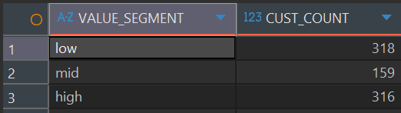

--customer segmente gore musterilerimizin sayina baxaq:

SELECT
CUST_SEG,
COUNT(CUSTOMER_ID) AS cust_count
FROM RFM_ANALYSIS
GROUP BY CUST_SEG
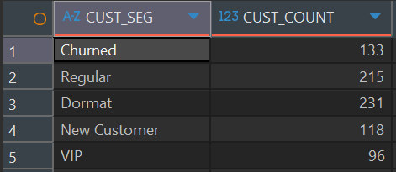
--her segmentdeki musteriler umumi segmentin nece faizini teskil edir?
